Dr. William H. Brewster Elementary School

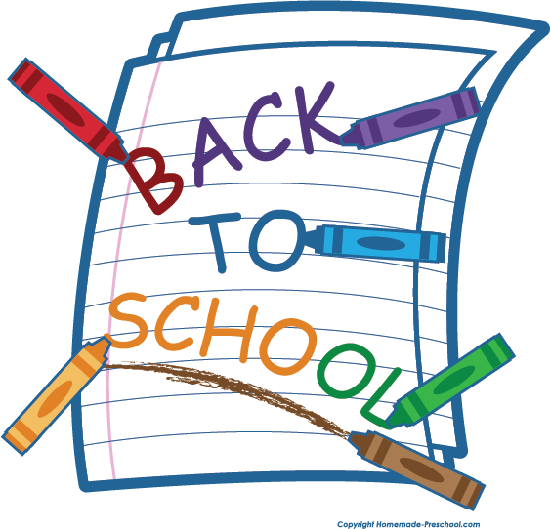

2023-2024 School Supply Lists

|  |  |
| --- | --- |
| Kindergarten  4 packs 24 count Crayola Crayons  1 pair Fiskar Blunt Tip scissors  1 pack 24 count pencils  12 pack Glue Sticks  4 Black or Blue Expo Dry Erase Markers 2 Boxes of Kleenex tissue  1 container Clorox Wipes  1 pack of Quart Ziploc Bags  1 pack of Gallon Ziploc Bags  3 Reams of Copy Paper  1 pair of headphones (NO EARBUDS! NO BLUETOOTH!)  1 change of clothes (Please label and include underwear and socks)  1 backpack (no mini backpacks or rolling backpacks)  ***In addition keep the following supplies at home for homework and projects.*** pencil, crayons, scissors, glue stick, paper | 1st Grade  Backpack  2 boxes of 24 Crayola Crayons  2 pkgs. of 4 count Expo Markers (Black)  2 pkgs. of Pencils (24 count)  1 Primary Composition Journal  3 reams copy paper  4 boxes of Kleenex  2 Clorox Wipes  2 pencil pouches  1 pack of Quart Ziploc Bags  1 pack of Gallon Ziploc Bags  1 pair of headphones (NO EARBUDS! NO BLUETOOTH!) |
| 2nd Grade  1 pair of headphones (not wireless)  2 boxes of Kleenex  1 box Gallon Ziploc Bags  1 Box Sandwich Ziploc bags  3 Boxes of Crayola Crayons  3 Large Glue Sticks  3 Reams of Copy Paper  24-48 pencils  1 roll of paper towels  1 container of Disinfecting Wipes  3 Spiral Notebooks  8 BLACK Dry Erase Markers  2 Vinyl/Plastic Folders with pockets and brads  1 package of Crayola Markers  1 package of colored pencils  1 pair Blunt scissors  1 Pencil box that fits inside of desk  2 Pencil Pouches with three holes to go inside binder  **Optional Class (All of the above items as well as the items listed below.)**  3 Highlighters (Color does not matter)  3 pens (Blue, Black, Red)  1 Pack of Addition Flash Cards (at least to 20)  1 Pack of Subtraction Flash Cards (at least to 20) | 3rd Grade  1 Full Size Backpack  1 ½” binder with view pocket  4 folders with HOLES for binder (Blue, Red, Yellow, Green)  4 Folders with prongs and pockets (Blue, Red, Yellow, Green)  4 24 count #2 pencils  2 Boxes of Kleenex  4 Glue Sticks  2 Boxes of 24 ct. crayons  1 Pencil box (big enough to hold scissors, pencils, glue stick, and crayons)  1 Pair of blunt-end scissors  1 Package of eraser tops  2 Reams of copy paper  1 Package of 4 dry erase markers  1 Set of Headphones  1 Box of gallon size baggies  1 box of sandwich size baggies  1 Bottle of sanitizer  1 Container of Clorox Wipes  **Optional Class (All of the above items as well as the item listed below.)**  1 set of Multiplication Flash Cards |
| 4th Grade  2 boxes of Kleenex  1 ream of copy paper (500 sheets)  1 pack of highlighters (multi-colored)  1 pack of pencils (No mechanical pencils)  1 pack of dry erase markers  1 bottle of hand sanitizer  1 bottle of Lysol wipes  1 Composition book  1 pencil pouch or box  4 One-Subject Notebooks with pockets (green, red, blue, yellow)  2 packs of loose leaf paper  **Optional Class:**  2 boxes of Kleenex  1 ream of copy paper (500 sheets)  1 pack of highlighters (multi-colored)  2 packs of pencils (No Mechanical Pencils)  1 pack of dry erase markers  1 bottle of hand sanitizer  1 bottle of Lysol wipes  1 Composition book  1 pencil pouch or box  2 One-Subject Notebooks with pockets (green, yellow)  2 packs of loose leaf paper  1 pack of colored pencils  2 Three or Five Subject Spiral Notebook (blue, red) | 5th Grade  5 packs of loose-leaf notebook paper  2 packs of USA Gold or Ticonderoga pencils  3 boxes of Kleenex  2 pack of EXPO dry erase markers  1 large bottles of hand Sanitizer  2 reams of copy paper (500 Count)  1 pack of sheet protectors  1 earbud headphone (labeled w/ name)  1 pack of Gallon zip lock bags  1 pack of quart zip lock bags  2 containers of Clorox wipes  1 pack pencil erasers  1 Pencil Pouch/Box  5 Folders w/ Prongs and Pockets (red, blue, yellow, green, orange)  1 Water Bottle (Labeled w/ Name)  2 3-Subject Spiral Notebooks |